**Apache Kafka**

Apache Kafka is a fast and scalable messaging queue, capable of handling heavy loads in context of read and write, i.e. IO-related, stuff. You can find more about Kafka on [http://kafka.apache.org/](http://kafka.apache.org/" \t "_blank)

Apache Kafka requires a running ZooKeeper instance, which is used for reliable distributed coordination. Please find more about ZooKeeper on [https://zookeeper.apache.org/](https://zookeeper.apache.org/" \t "_blank).

Download the following files before running kafka:

* Download JRE according to your machine :

[http://www.oracle.com/technetwork/java/javase/downloads/jre8-downloads-2133155.html](http://www.oracle.com/technetwork/java/javase/downloads/jre8-downloads-2133155.html" \t "_blank)

* Install JRE set the system variable
* Download and extract ZooKeeper from [http://zookeeper.apache.org/releases.html](http://zookeeper.apache.org/releases.html" \t "_blank)
* Download and extract Kafka

from [http://kafka.apache.org/downloads.html](http://kafka.apache.org/downloads.html" \t "_blank)

Process of Running Kafka (Script used during demo) :

1)Open command line and go to kafka folder

2)And change the directory to the path you have saved the kafka

3)And enter the command to start zookeeper.

.\bin\windows\zookeeper-server-start.bat .\config\zookeeper.properties

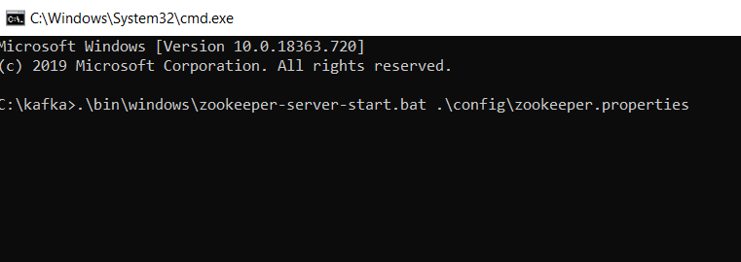

4)Now Start Kafka server in a separate command line.

.\bin\windows\kafka-server-start.bat .\config\server.properties

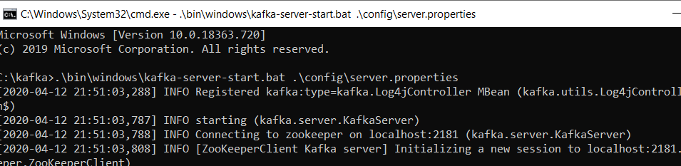

5)Now Create a topic with the command

\bin\windows\kafka-topics.bat --create --zookeeper localhost:2181 --replication-factor 1 --partitions 1 --topic Topic

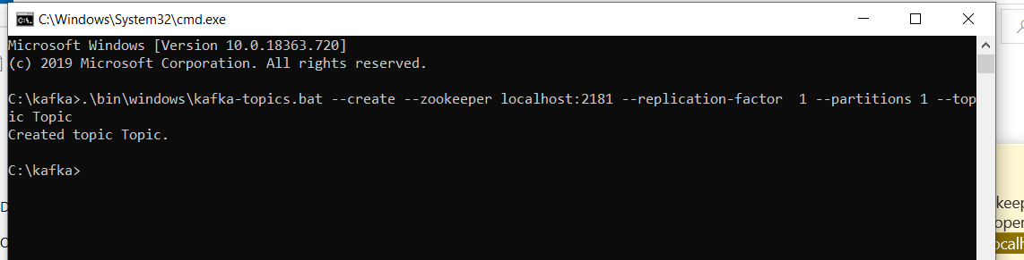

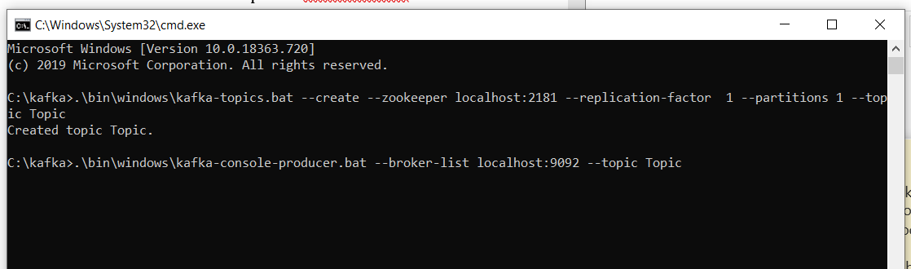

6)Start Producer with the command as shown in above fig.

.\bin\windows\kafka-console-producer.bat --broker-list localhost:9092 --topic Topic

7)Start Consumer with

.\bin\windows\kafka-console-consumer.bat --bootstrap-server localhost:9092 --topic TestTopic1 --from-beginning

And send a message through producer and receive it in consumer.

